VCS Task

Task Description:

Establish a new directory, populate it with script files, initiate an empty repository on GitHub, convert the local directory into a Git repository, and link it to GitHub for pushing the code into the repository.Perform merge, rebase, stash commands in following github repo
Techstacks needs to be used :
- Shell (AWS, WSL, Vbox)
- Git (Gitbash)
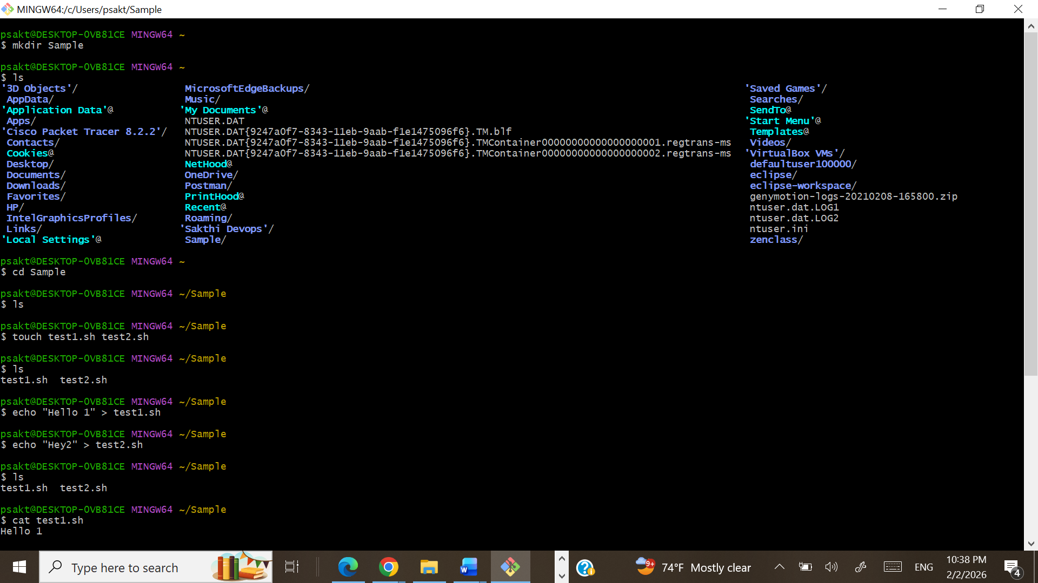
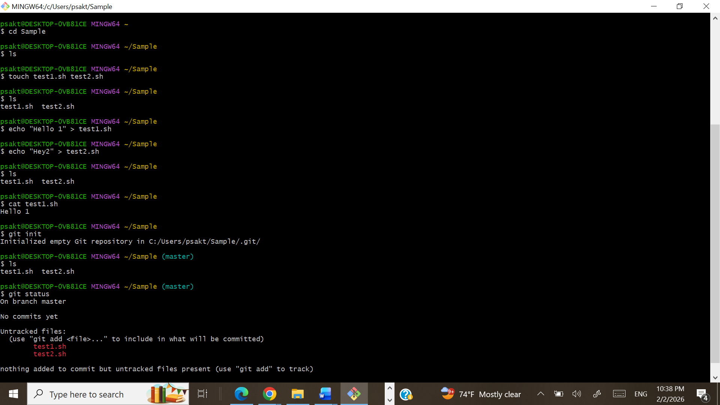

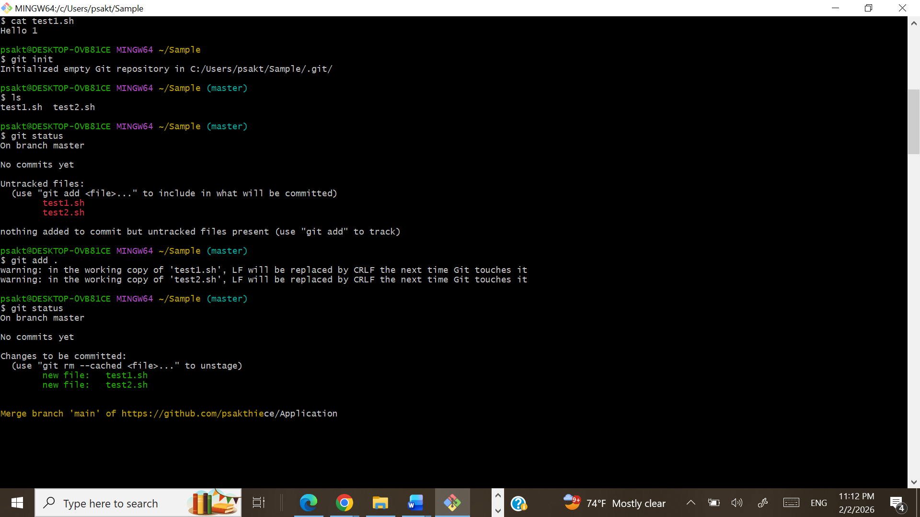

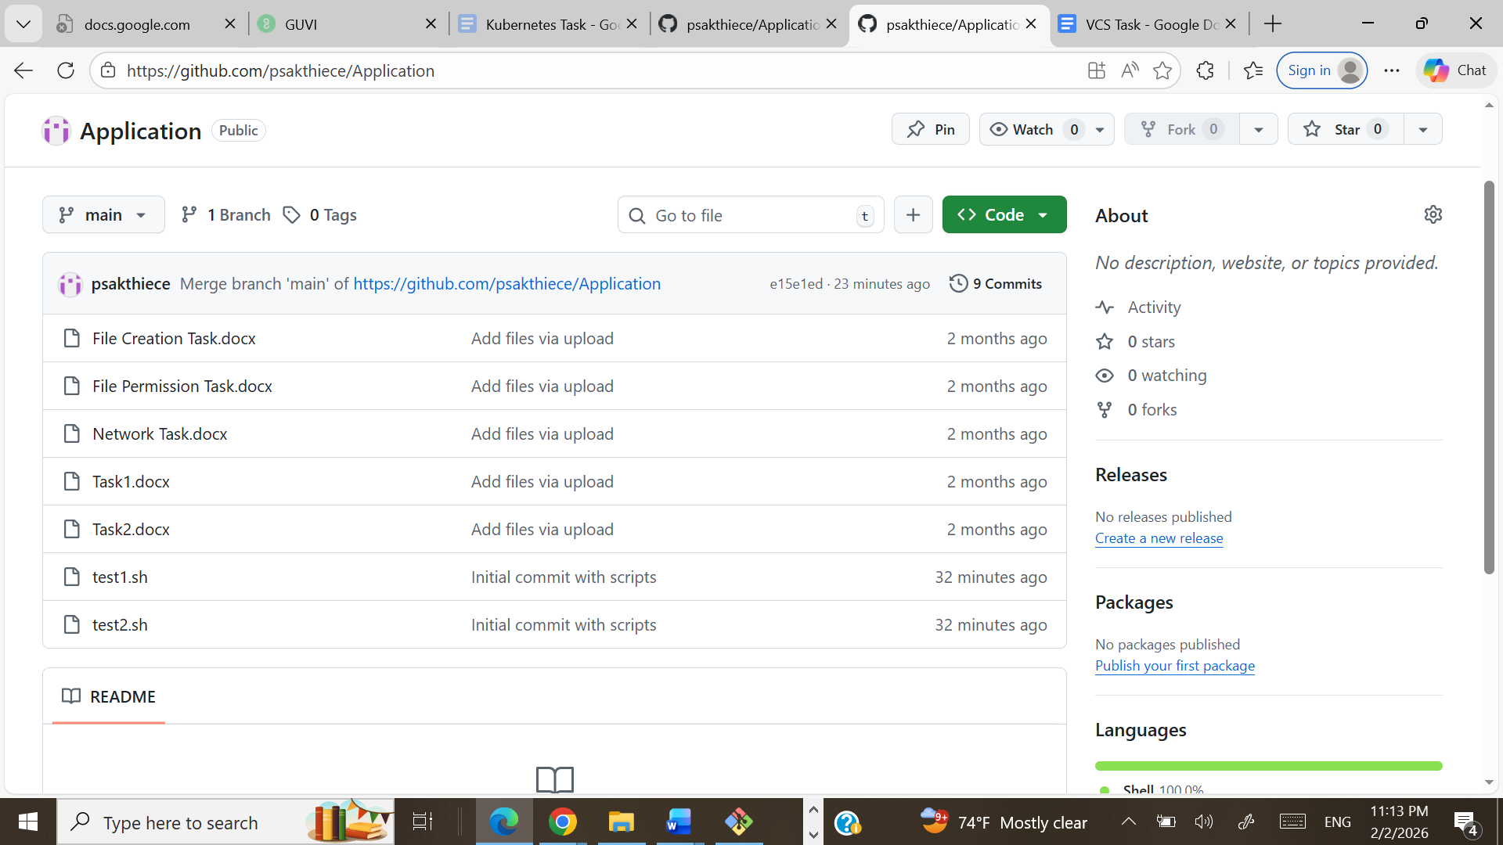
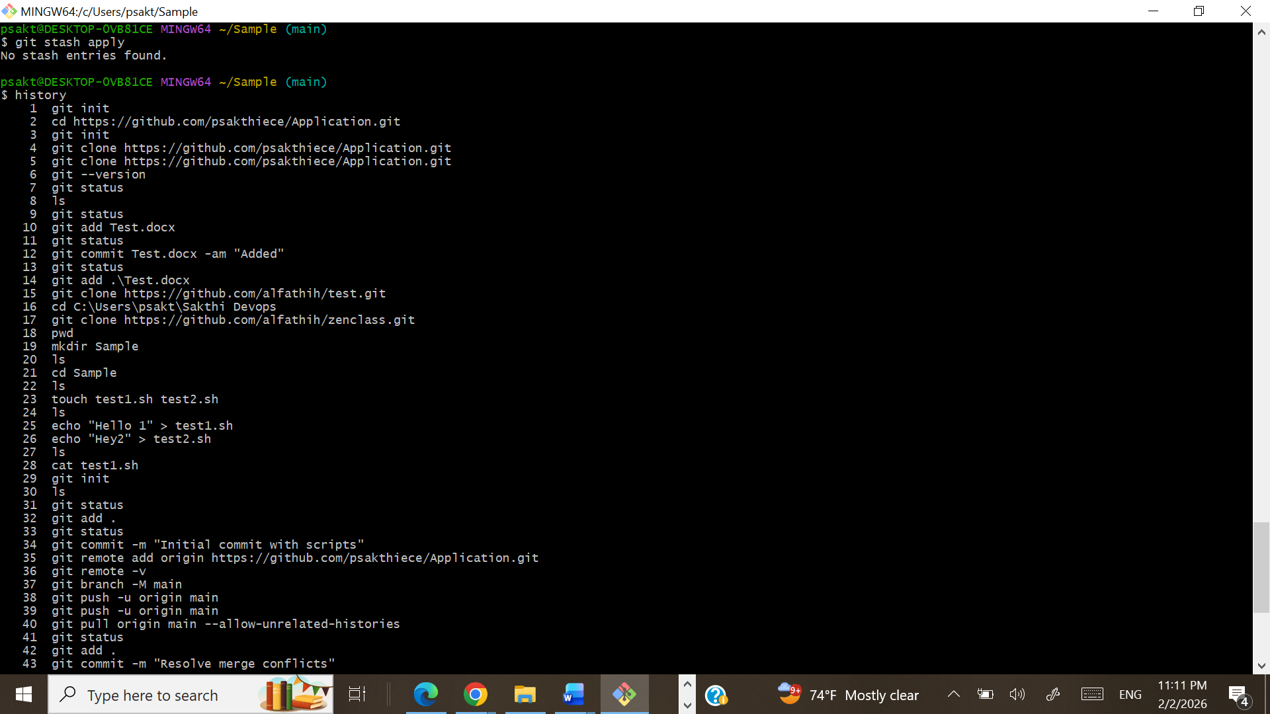
$ history
1 git init
2 cd https://github.com/psakthiece/Application.git
3 git init
4 git clone https://github.com/psakthiece/Application.git
5 git clone https://github.com/psakthiece/Application.git
6 git --version
7 git status
8 ls
9 git status
10 git add Test.docx
11 git status
12 git commit Test.docx -am "Added"
13 git status
14 git add .\Test.docx
15 git clone https://github.com/alfathih/test.git
16 cd C:\Users\psakt\Sakthi Devops
17 git clone https://github.com/alfathih/zenclass.git
18 pwd
19 mkdir Sample
20 ls
21 cd Sample
22 ls
23 touch test1.sh test2.sh
24 ls
25 echo "Hello 1" > test1.sh
26 echo "Hey2" > test2.sh
27 ls
28 cat test1.sh
29 git init
30 ls
31 git status
32 git add .
33 git status
34 git commit -m "Initial commit with scripts"
35 git remote add origin https://github.com/psakthiece/Application.git
36 git remote -v
37 git branch -M main
38 git push -u origin main
39 git push -u origin main
40 git pull origin main --allow-unrelated-histories
41 git status
42 git add .
43 git commit -m "Resolve merge conflicts"
44 git push origin main
45 git checkout -b feature-merge
46 echo "Hello sakthivel modified file" > test1.sh
47 git add test1.sh
48 git commit -m "Add merge feature"
49 git checkout main
50 git merge feature-merge
51 git checkout -b feature-rebase
52 git commit -m "Resolve merge conflicts"ec
53 echo
54 idddddddddddddddddd
55 echo "Hey sak modified" > test2.sh
56 git add test2.sh
57 git commit -m "Add rebase feature"
58 git checkout main
59 git rebase feature-rebase
60 git status
61 git stash
62 git stash list
63 git stash apply
64 history

